Developer Documentation

Overview
Software source code can be located at tippacanoe/Blackjack-Trainer. All Unity scripts were compiled in C# v.17. There are 7 script files for the whole project, these are: ModeTracker.cs, menus/MenuManager.cs, logic/Card.cs, logic/Deck.cs, logic/GameManager.cs, logics/Hand.cs, and logic/HandDisplay.cs. All scripts can be found in Assets/Scripts/.

Project Editing Requirements
- Compiler: C# v.17
- Unity Editor: 6000.2.9f1
- 8+ GB RAM
- JavaScript compatible web browser
- Unity Web Build support
Script Descriptions
Game flow is largely handled by GameManager.cs script. This manages most of how the Blackjack game flow works. It includes button management, text display, deck management, dealer plays, and hand comparisons.
ModeTracker.cs is a static data structure used to keep track of the current mode in the Blackjack scene. This is set by the main menu when the mode is selected, and determines what text (if any) is shown in the Blackjack game.
MenuManager.cs manages the menus in the main menu and enables/disables the tutorial text screen. This largely is a collection of functions that show/hide the correct buttons.
Card.cs is the card data structure used in the Blackjack scene. Every card has a prefab in Unity. The prefabs are assigned a rank, suit, and sprite through Card.cs. The suit is purely aesthetic. Rank is the value of the card (A, 2, 3, 4, etc.). Sprite is the sprite assigned to the card, and is what is shown on the screen. Deck object is a collection of the card objects.
Deck.cs is the deck data structure. This contains the linked list of card objects. It handles shuffling the deck and returning a card when cards are drawn. Additionally, deck shuffling is implemented in a quick way. The deck data structure does not truly shuffle ever, meaning there is never a point in the script where the code is attempting to reorganize a 52-element array at random. Instead, when a card is drawn from the deck (either by player or dealer), a random number from 0 to the length of the array is chosen, and that card is drawn from the deck causing it to be removed from the data structure. When the deck needs to be “shuffled” it is simply reset back to its default state. This is very fast.
Hand.cs is the hand data structure. This contains the list of cards in each player’s hand, and is how the game compares who wins each round. It has functionality to add cards to the list, clear the list, and counts aces correctly in all cases. It also checks if the hand count type is hard (no aces that count as 11) or soft (contains aces that count as 11).
HandDisplay.cs provides functionality to get the sprites associated with each card and show them in the relevant sections on the screen in the Blackjack scene.
Line counts for all scripts are listed below. You can find more detailed descriptions on the scripts in the developer documentation.

Script | Line Count
GameManager.cs | 301
ModeTracker.cs | 34
MenuManager.cs | 95
Card.cs | 21
Deck.cs | 53
Hand.cs | 142
HandDisplay.cs | 73
TOTAL | 719

Some scripts were longer than they currently are in their initial implementations, but I have simplified them to be shorter. This makes them easier for programmers to read while maintaining the same functionality. More lines does not necessarily mean better code, or more mechanics.

Unity and logic structure
There are two scenes in the game, BlackjackScene and MainMenuScene. MainMenu scene is the game scene shown when a player first starts the game. BlackjackScene is what plays Blackjack. MainMenuScene only interfaces with the MainMenu.cs and ModeTracker.cs scripts. BlackjackScene interfaces with all scripts except MainMenu.cs.

Card prefabs are all found in Resources/Prefabs/Blackjack. Card prefabs are broken up by suit in separate folders (Spades, Clubs, Diamonds, Hearts). There is a hand prefab, which is where sprites are stored from cards in the actively played hands and allows them to be displayed on the screen.

Very little code in the scripts runs on Update in Unity, this maximizes performance as code is only executed from scripts when there is direct user input in the game. Update executes on every frame and can be very costly on performance, so this has been avoided. Instantiate is used instead of New keyword in some circumstances where prefabs are needed. This has to do with how Unity handles object initialization for prefabs, where it can instantiate but struggles to create new objects. Secure programming principles are adhered in the scripts. Variables are marked private where applicable, and can only be viewed and mutated by related getters and setters.
Functions are used in every script for logic. Every function is prefaced with a comment describing what it is for. Throughout the more complex functions, there are comments describing what certain lines of code do and why they were implemented. Camel casing is widely used across the project.
Game flow
The dealer is an automated player. This is handled in the GameManager.cs script. When the player finishes playing (either by selecting the stand button, or busting when selecting the hit button) the player’s turn is over and the dealer plays with the playDealer function. Dealer checks to see if the hand value is >=17. If not, it will keep drawing cards until this condition is true. Once the dealer’s turn is over (hand value >=17), the dealer’s hidden card is revealed to the player, and the hands are compared. This is handled by the endRound function. When starting the round, the game checks to see if there are enough cards left in the deck (at least 10).
Also of note are how aces are counted. Aces are ranked as ‘11’ in the system. When the hand value is being calculated (updateHandTotalValue in Hand.cs), if an 11 is detected the system will only add 1 rank to the hand, and increment an ace counter. After all cards in the hand have been counted, the code will check to see if turning an ace into an 11 (instead of 1) will bust the hand value and if not, will add the remaining 10 points to the hand. It will do this for every ace.
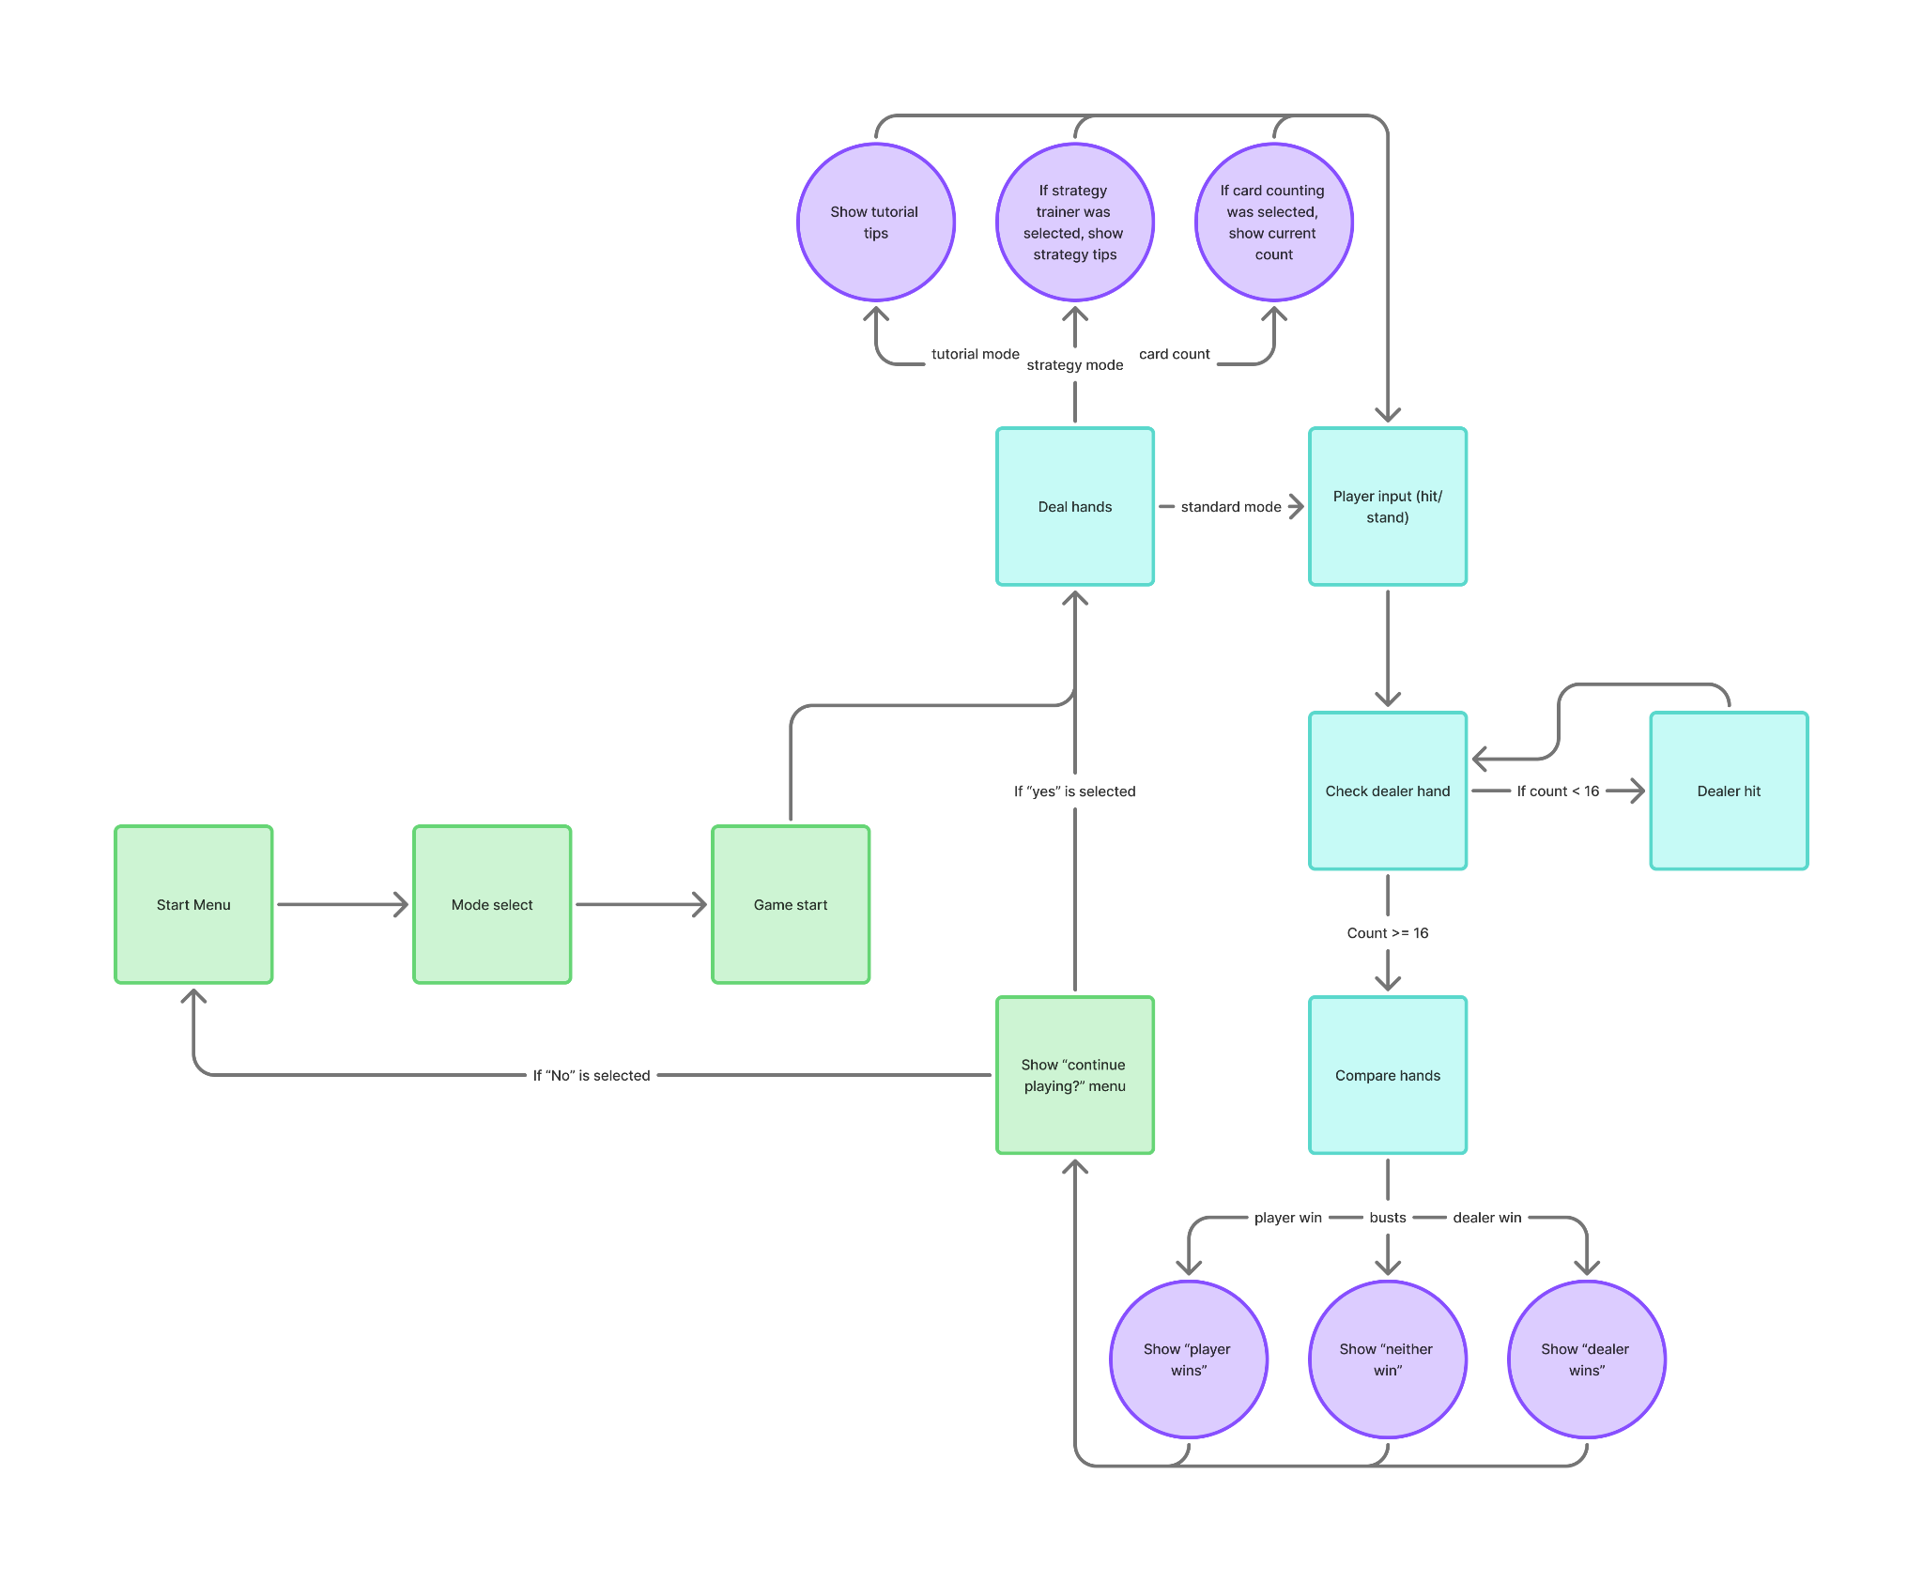

Card counting logic follows a simple High-Low system, where 10, J, Q, K, A all count as a -1, 2 - 6 counts as a +1, and everything else does not impact the count.

We used this chart to model the strategy tooltips (credit to Blackjack Strategy Charts - How to Play Perfect Blackjack):
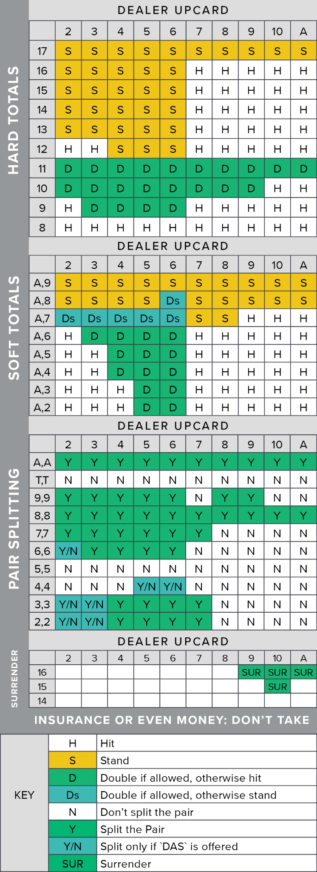

How to import
Download the project directory from the Github repository. Run Unity editor, and go to the projects screen. Click Add > Add from Disk. Point Unity to the top-level project folder you downloaded. Unity will import the project and began the editor build for you.

How to build
In the editor, go to:
> File > Build Profiles > Web > Click “Open Scenes List”
> Add the MainMenu scene and ensure it is at index 0.
> Return to web build profiles. Select Build. It is going to open file explorer and ask you where to save the build. Create a new folder outside of your project for the build. Click select folder.

Unity will start building the project. This can take a while on slower systems. When it is done, you can zip the build folder, and upload it to a site like Itch.io for playback.

Licensing
Project is open source with MIT OSS license. More information can be found here: https://github.com/tippacanoe/Blackjack-Trainer/tree/main?tab=MIT-1-ov-file#readme

Misc.
All known bugs at this time are currently resolved. If more code should be implemented in the future, it should largely be built in new scripts as the existent scripts are complete. If more modes would be implemented, I would recommend pulling all of the card counting and strategy mode logic out of the GameManager.cs script and adding it to separate script files. Current build of the project is accessible on my profile on Itch.io: https://tippacanoe.itch.io/blackjack-trainer

